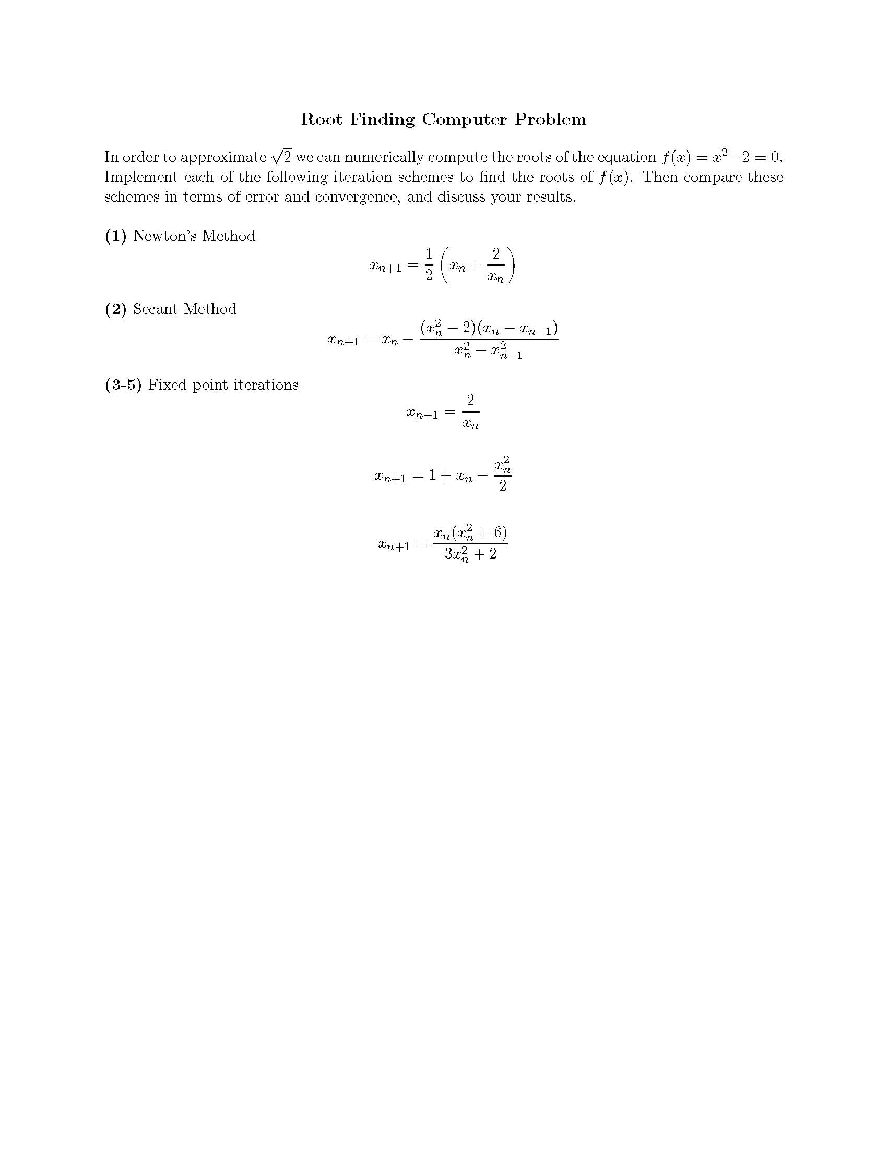

Method of solution:

Note: Since this problem is a computer problem in stead of a theory problem, I will not discussion anything from a theoretic manner. All my observation will be based on the computer program results.
We can easily find that the value of 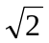is between 1 and 2. So our initial guesses for this value is in this range. For Newton and Fixed point iteration methods, I use x₀=1; and for Secant method, I use x₀=1 and x₁=2 as my initial guesses.

(1) First we write the code in Matlab using Newton’s Method (call it Newton_1.m). This coding is straight forward.
function [r]=Newton_1(x)
% Approximate sqrt(2) using Newton's Method,
% starting from x0=x

e=eps;
x0=x;
x1=f(x0);
i=1; % iteration counter
while (abs(x1-x0)>e) % until error less than epsilon
i=i+1;
x0=x1;
x1=f(x0);
end
r=x1;
n=i % output the number of iterations

function [a]=f(x)
% Given Xn, compute X_n+1. Using Newton

a=1/2*(x+2/x);

Testing our code use x₀=1 by typing in Matlab command line:
>> r=Newton_1(1)

n =

6

r =

1.4142

It is pretty impressive to observe that by only 6 iterations the machine epsilon is reached.

(2) Next we code for Secant Method, it is also straight forward (call it Secant_2.m).
Note that the formula can be simplified, we use the simplified formula in our coding.
function [r]=Secant_1(a,b)
% Approximate sqrt(2) using Secant Method,
% starting from x0=a and x1=b

e=eps;
x0=a;
x1=b;
x2=f(a,b);
i=1; % iteration counter
while (abs(x2-x1)>e) % until error less than epsilon
i=i+1;
x1=x2;
x0=x1;
x2=f(x0,x1);
end
r=x2;
n=i % output the number of iterations

function [a]=f(x0,x1)
% Given Xn-1, Xn, compute X_n+1. Using Secant

a=x1-(x1^2-2)/(x1+x0);

Testing our code using x₀=1 and x₁=2 by typing in Matlab command line:
>> r=secant_2(1,2)

n =

6

r =

1.4142
Secant method also takes only 6 iterations to reach the machine epsilon. Impressive, too!

(3) Having these codes, coding for (3)-(5) becomes very easy: we simply replace the last line in the coding of Newton’s Method and it is done. Here are the last lines for problem (3)-(5), respectively. These functions are named Fixedpoint_3, Fixedpoint_4, and Fixedpoint_5, respectively.
a=2/x; % Fixed point iterations (3)

a=1+x-x^2/2; % Fixed point iterations (4)

a=x*(x^2+6)/(3*x^2+2); % Fixed point iterations (5)

Testing these codes using x₀=1 by typing in Matlab command line:
>> r=Fixedpoint_3(1)

And the program hangs because this sequence oscillates instead of converges.

For (4) and (5), the corresponding output are as follows:
>> r=Fixedpoint_4(1)

n =

41

r =

1.4142

>> r=Fixedpoint_5(1)

n =

4

r =

1.4142
It shows that Method (4) converges slower (41 iterations) than Newton’s method and Secant method (6 iterations each), while Method (5) converges faster (4 iterations) than all the others.

To make it easier for side by side comparison, we summary these results in Table 1
Table 1: Method Comparison
Method | Newton | Secant | Fixed (3) | Fixed (4) | Fixed (5)
Iterations needed to get error less than machine epsilon | 6 | 6 | ∞ (don’t converge) | 41 | 4

Also interesting would be comparing the errors after each iteration to observe in detail how fast these methods converge. Thus we add the error estimation code in the programs and get the following results shown in Table 2 and illustrated in Figure 1. To save space, we only show the code for Newton’s method (see highlighted statements). The codes for others are similar.
function [r]=Newton_1(x)
% Approximate sqrt(2) using Newton's Method,
% starting from x0=x

root=sqrt(2);
e=eps;
x0=x;
x1=f(x0);
i=1; % iteration counter
while (abs(x1-x0)>e) % until (error <= machine epsilon)
error(i)=abs(x1-root);
i=i+1;
x0=x1;
x1=f(x0);
end
r=x1;
n=i % output the number of iterations

error % output the errors

function [a]=f(x)
% Given Xn, compute X_n+1. Using Newton

a=1/2*(x+2/x);

Table 2: Error Comparison
Iteration Number | Newton  x₀=1 | Secant  x₀=1, x₁=2 | Fixed (3)  x₀=1 | Fixed (4)  x₀=1 | Fixed (5)  x₀=1
0 | 0.41421 | 0.58579 | 0.41421 | 0.41421 | 0.41421
1 | 0.085786 | 0.08088 | 0.58579 | 0.085786 | 0.014214
2 | 0.0024531 | 0.0024531 | 0.41421 | 0.039214 | 3.644e-007
3 | 2.1239e-006 | 2.1239e-006 | 0.58579 | 0.015474 | 2.2204e-016
4 | 1.5947e-012 | 1.5947e-012 | 0.41421 | 0.0065292 | 0
5 | 2.2204e-016 | 0 | 0.58579 | 0.0026832 | 0
6 | 0 | 0 | 0.41421 | 0.001115 | 0
7 | 0 | 0 | 0.58579 | 0.00046123 | 0
8 | 0 | 0 | 0.41421 | 0.00019115 | 0
9 | 0 | 0 | 0.58579 | 7.916e-005 | 0
10 | 0 | 0 | 0.41421 | 3.2792e-005 | 0
11 | 0 | 0 | 0.58579 | 1.3583e-005 | 0
Table 2 clearly shows that Newton and Secant method converges at the same speed, while Method 4 converges slower than them and Method 5 converges the fastest.
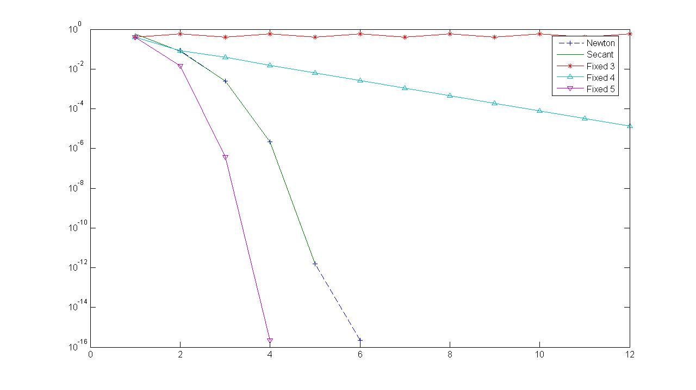
Figure 1: Error Comparison

Figure 1 shows that Fixed 4 method converges roughly in a linear manner, while Newton, Secant, and Fixed 5 methods converges faster than linear. Again, Fixed 3 does not converge at all.

All the above conclusions agree with each other.

Next we will study the impact of initial guesses on the converge speed of these methods. In order to make comparison easier, we tried the following initial values for x₀ and x₁ (note that x₁ works only for Secant method).

Table 3 Initial values for testing the convergence speed
x₀ | 1 | 2 | 3 | 4 | 5 | 10 | 20 | 30 | 50 | 100
x₁ | 2 | 4 | 9 | 16 | 25 | 100 | 400 | 900 | 2500 | 10000

The corresponding results are shown as follows:
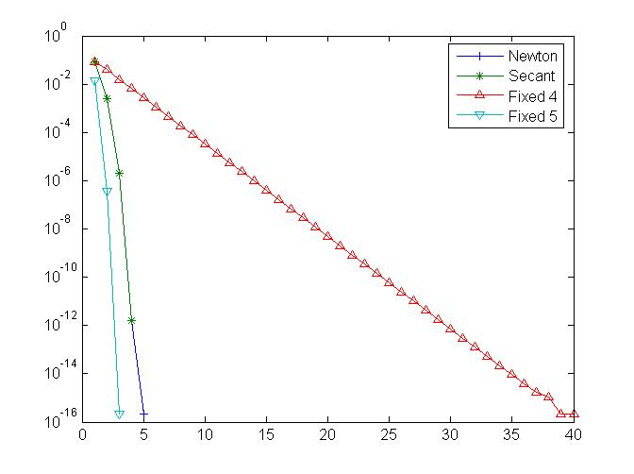
Figure 2: Error comparison x₀=1, x₁=2

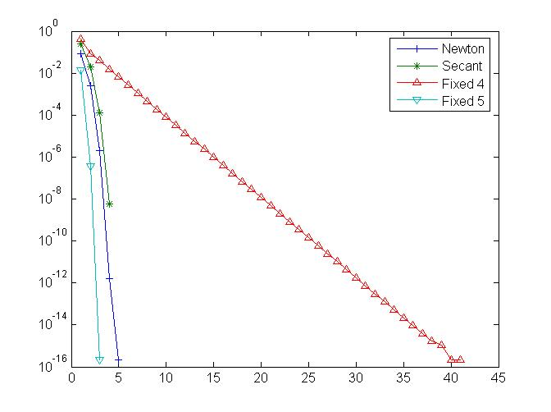
Figure 3: Error comparison x₀=2, x₁=4
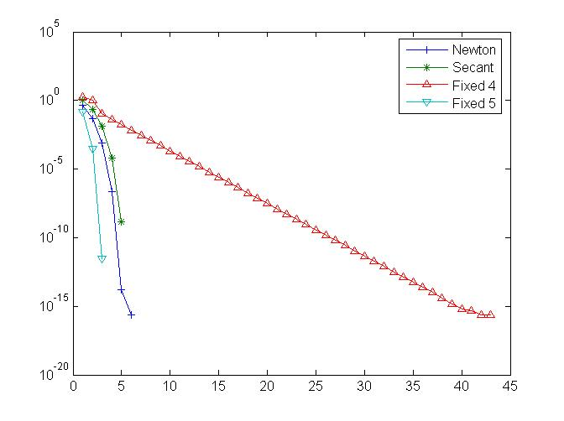
Figure 4: Error comparison x₀=3, x₁=9

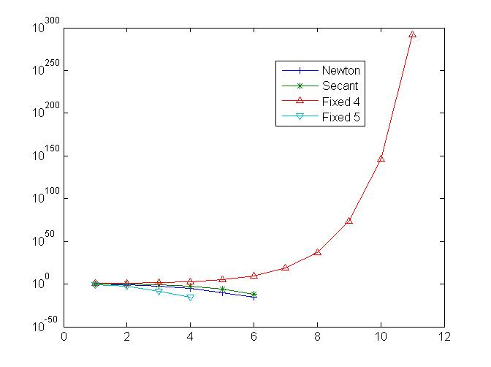
Figure 5: Error comparison x₀=4, x₁=16

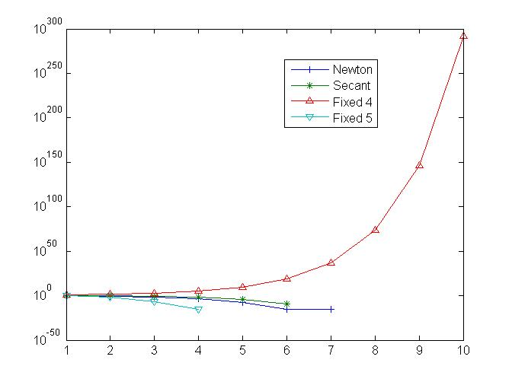
Figure 6: Error comparison x₀=5 x₁=25
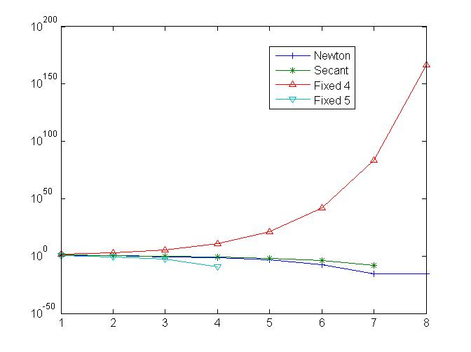
Figure 7: Error comparison x₀=10, x₁=100

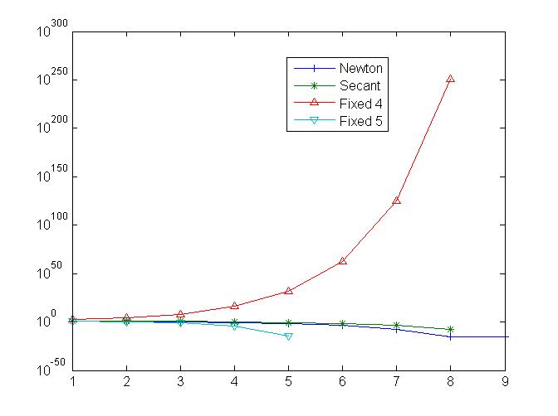
Figure 8: : Error comparison x₀=20, x₁=400

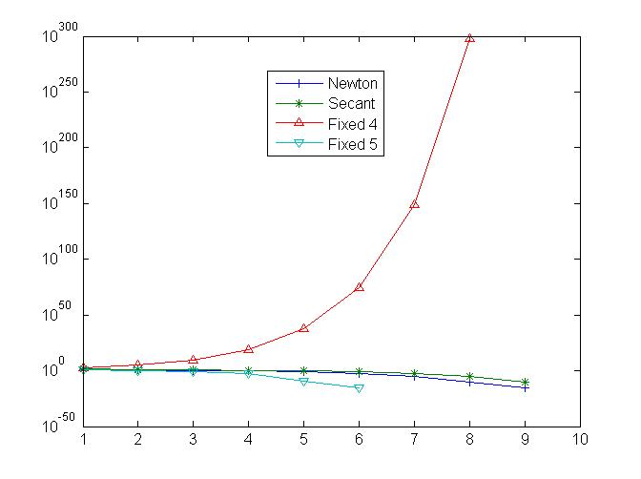
Figure 9: Error comparison x₀=30, x₁=900
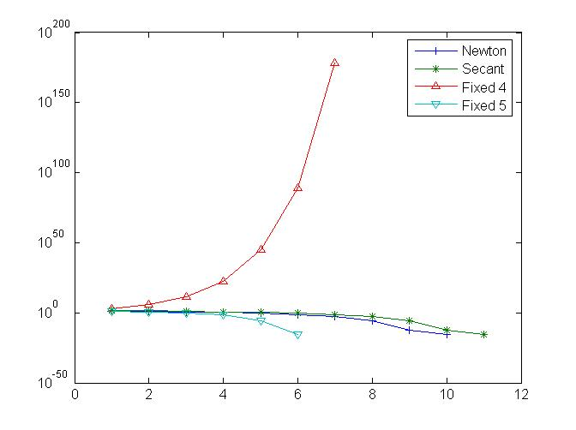
Figure 10: Error comparison x₀=50, x₁=2500

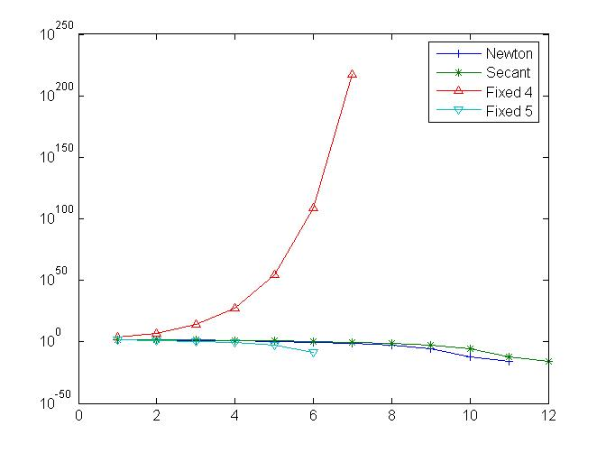
Figure 11: Error comparison x₀=100, x₁=10000

We did not show the results for Method 3 here since it never converges. A new findings from these figures is that Method 4 does not converge for large initial values (x₀ >= 4), while Newton, Secant and Method 5 always converges throughout all the tests. For those converging cases, the order of convergence is always Method 5>Newton=Secant>Method 4.

